**MULTIMEDIA LAB**

**JADAVPUR UNIVERSITY**

**INFORMATION TECHNOLOGY, 6TH SEM**

**NAME: - MIHIR CHOWDHURY**

**ROLL NO. : - 00201101040**

**ASSIGNMENT: - 01**

**TOPIC: - WORKING WITH COLOR AND PATTERN FILLS**

1. Opened the file “hydrant.tiff” from downloads.

C:\Users\User.ITMM-29\Desktop\Ahishek-033\hydrant_Original.tif

1. Using the Zoom tool zoomed 200% the head portion of the hydrant.
2. From select =>save selection and saved the selection with name “Mihir\_040”.
3. Loaded the selection “Mihir\_040”, and then selected “layer” option, then
4. “Adjustment layer” then “Hue/Saturation”, then selected Hue to -57, saved the file as Mihir\_040\_hydrant\_1.jpg and Mihir\_040\_hydrant\_1.psd.

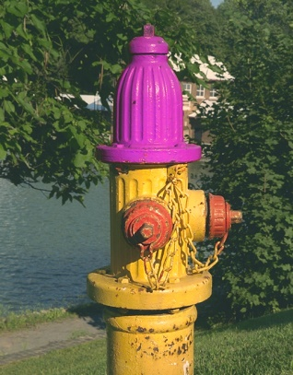

1. Then added more values to the previous selection, set the values of Hue to +100, saved the file as Mihir\_040\_hydrant\_2.jpg.

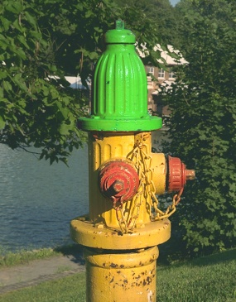

1. Then, selected pattern from Layer => Fill New Layer => Pattern.
2. Selected Pattern “Clouds” from pattern dialog box.
3. Saved two pattern files named as Mihir\_040\_hydrant\_3.jpg.

